Chapter 5, Problem 31

For the circuit in Fig. 5.69, find i_{x}.

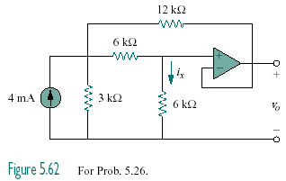

Figure 5.69
For Prob. 5.31.

